JIRA GFG
Section 1: Jira Introduction
What is Jira?
JIRA is a software development tool used for project management and issue tracking. It is a popular tool among software development teams to plan, track, and release software projects.
JIRA is a software development tool used for project management and issue tracking. It is a popular tool among software development teams to plan, track, and release software projects. JIRA provides a centralized platform for managing tasks, bugs, and other types of issues and it helps teams to organize and prioritize their work. The tool integrates with other software development tools and has a variety of customizable features and workflows that allow teams to adapt it to their specific needs. Additionally, JIRA also provides various reporting and dashboard features that help teams stay on top of their work and make data-driven decisions.
JIRA supports multiple languages including English, French, etc. It is a platform-independent tool. A 30-day free trial version is available on JIRA.
- JIRA provides a centralized platform for managing tasks, bugs, and other types of issues, and it helps teams organize and prioritize their work.
- The tool integrates with other software development tools and has a variety of customizable features and workflows that allow teams to adapt it to their specific needs.
- Additionally, JIRA also provides various reporting and dashboard features that help teams stay on top of their work and make data-driven decisions.
- JIRA supports multiple languages including English, French, etc.
- It is a platform-independent tool. A 30-day free trial version is available on JIRA.
What is Jira Board?
Jira provides different types of boards helping the software teams to manage and tracking of their work easily. Jira Boards is like a digital helping hand to make every process smooth and to the point ultimately helping the team to complete the project without making extra wastage of time. These boards help us to see which things are done and which things are yet to be done. Irrespective of the board you are using such as Scrum or Kanban they will help in making teamwork easier and work more Organized and transparent.
Jira Board is broadly classified into two types:
- Scrum Boards: This board is majorly used by Scrum teams to manage work. it helps in imagining the work in different stages such as from "To Do", "in Progress", "In Review" and finally into "Done". Scrum boards are widely used in the industry by the developer teams.
- Kanban Boards: These Boards do the major visualization part of the work. It has better visualization and ready-made templates that help the team look for better insights. and it also controls the number of tasks that can reside in the different development stages.
What is JIRA used for?
JIRA provides a centralized platform for managing tasks, bugs, and other types of issues, and it helps teams organize and prioritize their work. JIRA is designed for agile software development teams and it supports multiple methodologies such as Scrum, Kanban, and custom workflows.
JIRA is used for:
- Project Management: JIRA provides a centralized platform for managing software development projects, with support for multiple projects and workflows.
- Task Management: Teams can create, assign, and track tasks, bugs, and other types of issues.
- Agile Planning: JIRA supports agile methodologies such as Scrum and Kanban and provides tools for planning and tracking sprints, backlogs, and releases.
- Reporting and Dashboards: JIRA provides various reports and dashboards that help teams get a real-time view of their work and make data-driven decisions.
- Collaboration: JIRA allows teams to collaborate and communicate effectively, with features such as comments, notifications, and alerts.
JIRA is widely used by software development teams of all sizes and is known for its ease of use and customization capabilities. The tool offers a free trial and several pricing plans, including a cloud-based version and an on-premise version.
JIRA Issues:
What is an Issue?
An issue in Jira is a unit of work that needs to be completed. It can represent anything from a software bug to a project task to a helpdesk ticket. Issues are the building blocks of any Jira project, and they are used to track progress, assign tasks, and communicate with team members.
Issue keys
Issue keys are unique identifiers for every piece of work you track with Jira. They are easily recognizable and quick to remember.
One can see the issue keys:
- On issues themselves, as a label.
- In search results and saved filters.
- On cards on your boards or in a project's backlog.
- In links connecting pieces of work.
- In the issue's URL.
- Anywhere you need to reference the work you're tracking.
Issue keys are made up of two parts:
- The project key
- A sequential number
Project keys
Project keys are a series of alphanumeric characters that describe to people across your Jira site what pieces of work are related to your project. They're the most memorable and recognizable piece of an issue's identifier. For example, our team is codenamed Donut World. We use the project key "DONUT" to help people across Atlassian know and recognize work that relates to our team.
What are Issue Types?
Jira comes with a number of pre-defined issue types, such as bug, task, story, and epic. You can also create custom issue types to meet the specific needs of your project. Issue types are used to categorize issues and to control the workflow for each type of issue.
Jira issue types are used to categorize work items. They define the type of work that needs to be done, and the associated workflow.
The following are the standard issue types in Jira:
1. Epic
- Represents a larger body of work that can be broken down into smaller issues.
- Examples: Start a lemonade stand, develop a new software feature, launch a marketing campaign.
2. Story
- Represents a user requirement.
- Examples: As a lemonade enthusiast, I'd like to have a really cold, crisp drink. As a customer, I want to be able to easily find the products I'm looking for.
3. Task
- Represents a piece of work that needs to be done.
- Examples: Make lemonade, create sign, set up stand.
4. Bug
- Represents a problem that needs to be fixed.
- Examples: The lemonade is too sour, the website is not loading correctly.
5. Subtask
- Represents a smaller piece of work that is part of a larger issue.
- Examples: Squeeze lemons, mix ingredients, pour lemonade into cups.
What is Jira Issue Hierarchy?
Jira issues can be organized into a hierarchy, with parent issues and child issues. Parent issues represent larger pieces of work, while child issues represent smaller pieces of work that are part of the parent issue. The hierarchy can be used to track the dependencies between issues and to visualize the overall progress of a project.
1. Epic
- An epic is a large body of work that can be broken down into smaller, more manageable issues, such as stories, tasks, and bugs.
- Examples: Develop a new software feature, launch a marketing campaign, improve customer satisfaction.
2. Story
- A story is a user requirement or a piece of functionality that needs to be developed. Stories are typically written from the perspective of the user and describe what the user wants to achieve.
- Examples: As a user, I want to be able to easily find the products I'm looking for. As a customer, I want to be able to make a purchase with just a few clicks.
3. Subtask
- A subtask is a smaller piece of work that is part of a larger issue, such as a story or task. Subtasks can be used to break down complex work into smaller, more manageable chunks.
- Examples: Squeeze lemons, mix ingredients, pour lemonade into cups.
What is the Anatomy of an Issue?
Each Jira issue has a number of fields, including:
- Summary: A concise and clear explanation of the problem. This should concisely capture the main points of the problem.
- Description: An in-depth story that goes into further detail about the problem. It contains details like how to replicate a bug, how behavior should be expected vs what happens, or a thorough explanation of the task specifications.
- Status: The status describes that how the problem is currently being handled inside the workflow.
- Priority: The importance of a problem with regards to other problems is known as priority.
- Assignee: An assignee is an individual who is in charge of addressing the problem. It is the responsibility of this person to solve the problem through its lifecycle.
- Due Date: The time frame by which a resolution to the problem is to be completed. This helps in organizing and overseeing the project's schedule.
- Attachments: Documents, screensavers, and other resources with data that is linked to the problem are known as attachments.
- Comments: A space where team members can write notes, conversations, or updates about an issue. Team members can communicate and work together more easily as a result of this.
The issue layout is divided into three sections:
- Description: This is the first section that users see when they open an issue. It is a good place to put the most important fields, such as the issue summary, description, and priority.
- Field tabs: If the issue layout has more than one tab, they will be displayed in this section. Field tabs can be used to organize information that may be relevant to different teams, for example.
- Context fields: These are fields that are not always displayed in the issue view. They are only displayed when they have a value.
What are Parent and Child Issues?
Parent issues and child issues are two types of issues that are related to each other.
- Parent Issues: A parent issue is a larger piece of work that has one or more child issues. Parent Issues are considered as more complex assignments that are frequently linked to larger projects.
- Child Issues: Child issues are smaller pieces of work that are part of the parent issue. Smaller actions that are necessary to finish the Parent Issue are called Child Issues. They offer the specific actions or elements required to fulfil the more general objective specified by the Parent Issue.
For example, a parent issue might be a "new feature" issue, while the child issues might be "design the feature," "code the feature," and "test the feature."
What are Linked Issues?
Linked issues are two or more issues that are related to each other, but they are not parent/child issues. For example, you might link a bug issue to a story issue if the bug is preventing the story from being completed.
Linked issues can be used to track dependencies between issues and to visualize the overall relationships between issues.
The following are the out-of-the-box issue associations in Jira:
- Blocks/is blocked by: This association is used to show that one issue blocks another issue. For example, if an issue is waiting for the completion of another issue, you can use the blocks association to show the relationship.
- Clones/is cloned by: This association is used to show that one issue is a clone of another issue. For example, if you create a new issue that is based on an existing issue, you can use the clones association to show the relationship.
- Duplicates/is duplicated by: This association is used to show that one issue is a duplicate of another issue. For example, if you create a new issue that is essentially the same as an existing issue, you can use the duplicates association to show the relationship.
- Relates to: This association is used to show that one issue is related to another issue in some way. For example, if two issues are part of the same project, you can use the relates to association to show the relationship.
Create and Work with Issues
To create an issue in Jira, you can use the "Create Issue" button in the top navigation bar.
- You will need to select the issue type, enter a summary and description, and set the status, priority, and assignee.
- Once you have created an issue, you can work with it by editing the fields, adding attachments, and leaving comments.
- You can also move the issue through the workflow by transitioning it to different statuses.
Jira issues are a powerful tool for tracking work and managing projects. By understanding the different aspects of Jira issues, you can use them to improve your team's productivity and efficiency.
Steps to Create Issues
1. Create a new JIRA issue for each bug or defect you find.
2. The issue should include the following information:
- A brief description of the bug or defect.
- The steps to reproduce the bug or defect.
- The expected results.
- The actual results.
- The severity of the bug or defect.
3. Assign the issue to the appropriate developer or tester.
4. Track the progress of the issue until it is resolved.
5. Once the issue is resolved, close the JIRA issue.
Process to Work with Issues
The following is a general process for using JIRA issues for software testing:
- Create a new JIRA issue for each bug or defect you find.
- Assign the issue to the appropriate developer or tester.
- Track the progress of the issue until it is resolved.
- Once the issue is resolved, close the JIRA issue.
====================================================================================

Jira Epic
What is Jira Epic?
Epic in Jira provides an overview of the task that needs to be done. Epic shows the path to achieving a particular target for the team by showing the major goals and objectives of the project. Within this epic, you can create small tasks that can be assigned to individual team members so that everyone in the team can contribute towards the goal. This structure helps manage the product easily and gives a clear overview of the project's progress.
Why is Jira Epic Useful?
- High-Level Overview: Creating an Epic in Jira helps in managing the project with a top-down approach
- Better Visualisation: Creating an Epic will help in better visualization of your goal and objective.
- Task Association: Many small tasks are associated with Epic making it easier to manage.
- Project Tracking: Epic helps check the project status and ensure its destination.
When to Use Jira Epics?
- Large Projects: Epics are used when the project is large and requires multiple phases in execution.
- Collaboration: Different mode of communication medium is given within Epic so that the team can collaborate easily within the project
- Product Development: Epics comes with various features and updates in the software that can help in product development.
Tips of creating Jira epics
- Must have a clear and well-defined objective.
- Always include a good description or summary.
- Break the larger task into smaller manageable chunks.
- Assign work to the appropriate team player.
- Monitor/Update the progress of the Project.
====================================================================================
Agile vs. Jira
What is Agile?
Agile Software Development is a software development methodology that values flexibility, collaboration, and customer satisfaction. It is based on the Agile Manifesto, a set of principles for software development that prioritize individuals and interactions, working software, customer collaboration, and responding to change.
Agile Software Development is an iterative and incremental approach to software development that emphasizes the importance of delivering a working product quickly and frequently. It involves close collaboration between the development team and the customer to ensure that the product meets their needs and expectations.
Advantages of Agile
- Improved quality and reliability: Agile methodologies place a strong emphasis on testing, quality assurance, and continuous improvement. This helps to ensure that software is delivered with high quality and reliability, reducing the risk of defects or issues that can impact the user experience.
- Enhanced customer satisfaction: Agile methodologies prioritize customer satisfaction and focus on delivering value to the customer. By involving customers throughout the development process, teams can ensure that the software meets their needs and expectations.
- Increased team morale and motivation: Agile methodologies promote a collaborative, supportive, and positive work environment. This can lead to increased team morale, motivation, and engagement, which can in turn lead to better productivity, higher quality work, and improved outcomes.
Disadvantage of Agile
- Lack of predictability: Agile Development relies heavily on customer feedback and continuous iteration, which can make it difficult to predict project outcomes, timelines, and budgets.
- Limited scope control: Agile Development is designed to be flexible and adaptable, which means that scope changes can be easily accommodated. However, this can also lead to scope creep and a lack of control over the project scope.
- Lack of emphasis on testing: Agile Development places a greater emphasis on delivering working code quickly, which can lead to a lack of focus on testing and quality assurance. This can result in bugs and other issues that may go undetected until later stages of the project.
- Risk of team burnout: Agile Development can be intense and fast-paced, with frequent sprints and deadlines. This can put a lot of pressure on team members and lead to burnout, especially if the team is not given adequate time for rest and recovery.
- Lack of structure and governance: Agile Development is often less formal and structured than other development methodologies, which can lead to a lack of governance and oversight. This can result in inconsistent processes and practices, which can impact project quality and outcomes.
What is Jira?
Jira is a product management tool developed by Atlassian company. This tool helps a group of people to work on a project, it is like a virtual guide that will assist the team to work by following a decided path. It helps in creating, assigning, or setting deadlines for a particular task. It is commonly used in software development to get work done efficiently and in an organized manner.
Advantages of Jira
- Issue Tracking: Its issue tracking feature makes this tool ahead of others, you can easily create, prioritize, and track issues.
- Integration: It has a wide range of tools and services including version controlling systems and integration tools.
- Custom Fields: To capture specific information Jira provides the feature of making custom fields.
- Powerful Search and Reporting: Jira provides a robust search and reporting tool. You can sort issues and create custom reports.
- Agile Support: Jira provides tools like sprint planning and backlog management making it an excellent choice for Agile development.
Disadvantages of Jira
- Complexity: Jira can be complex to set up for beginners. Creating customization may require the help of an expert.
- Learning Curve: New users may find learning Jira to be a steep curve. Especially, if you are not comfortable with agile methodology.
- Cost: Jira is free for small teams, but it costs more when you require more features.
- Performance Issue: In some cases, when Jira is handling numerous concurrent users it may experience performance issues.
- Overhead: Managing Jira can create administrative overhead. Regular maintenance and troubleshooting can be resource-intensive.
Agile vs. Jira
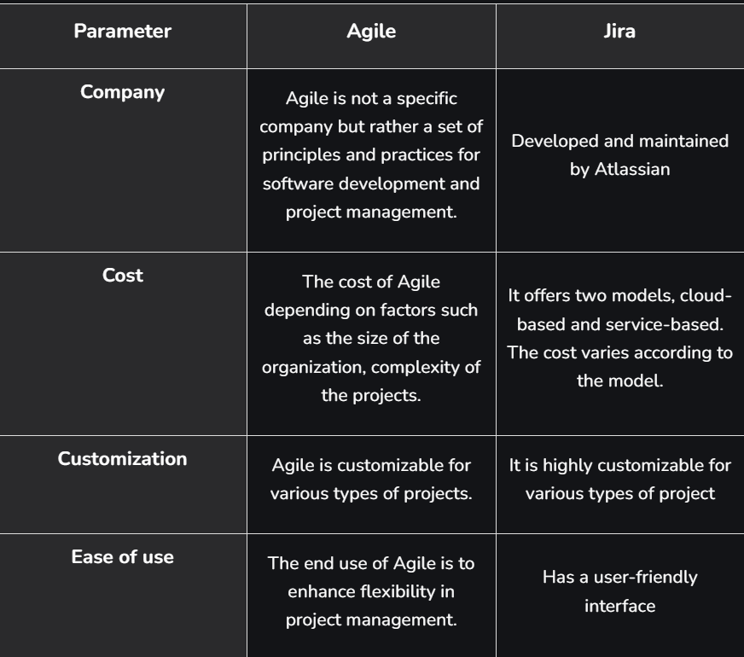
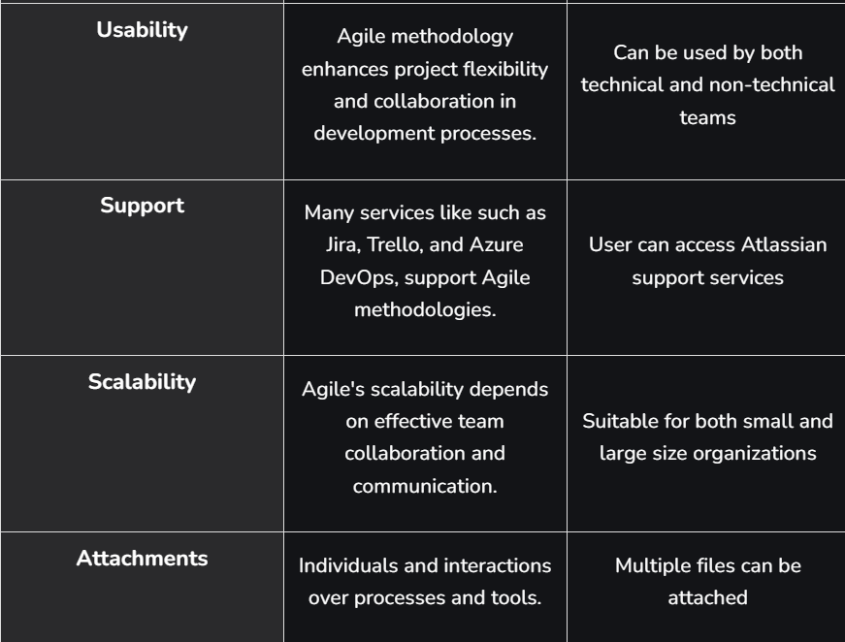
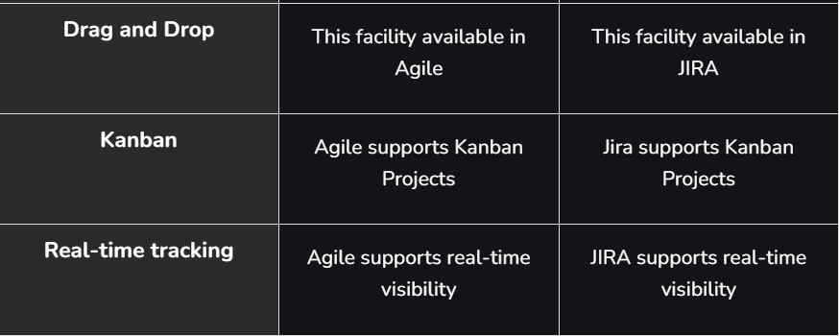
When to Choose Jira?
- If your team has both technical and non-technical members
- If you require more customization
- If you want more features apart from Bug tracking
- If you want wide variety of integration with software tools
- If you are dealing with large projects with different teams.
When to Choose Agile?
- When frequent modifications need to be made, this method is implemented.
- When a highly qualified and experienced team is available.
- When a customer is ready to have a meeting with the team all the time.
- when the project needs to be delivered quickly.
- Projects with few regulatory requirements or not certain requirements.
====================================================================================

